網內183費用計算

Create procedure CHT_網內183費用計算

as

begin

select [CHT_voiceTime1].[customer phone number],[CHT_voiceTime1].[receiver phone number],[CHT_voiceTime1].[start time],[CHT_voiceTime1].timespan,[CHT_Customer].[Fee type],[CHT_voiceTime1].timespan*0.07 as 網內費用

from [CHT_voiceTime1],[CHT_Buddy],[CHT_Customer]

where [CHT_voiceTime1].[receiver phone number]=[CHT_Buddy].[telephone number] and

[CHT_voiceTime1].[customer phone number]=[CHT_Customer].[Telephone Number] and [CHT_Customer].[Fee type]=183

end

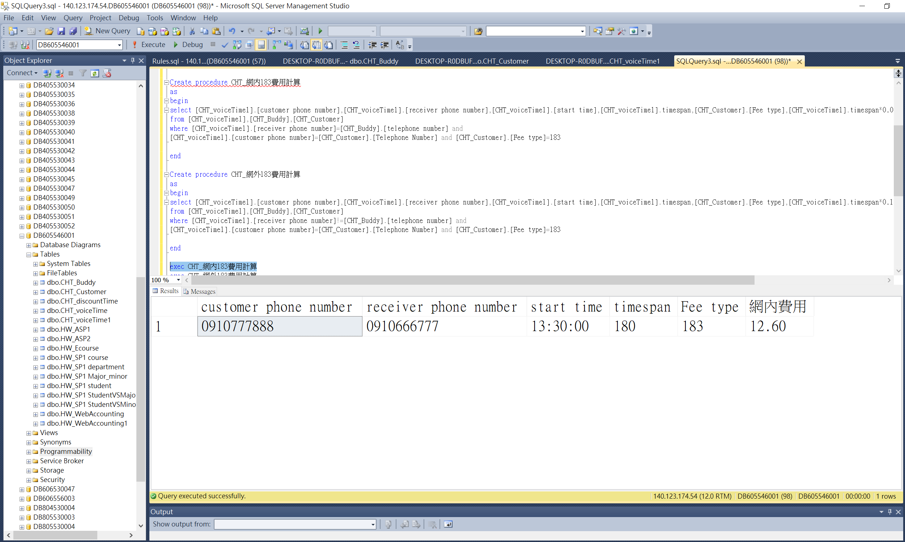

CHT_網外183費用計算

Create procedure CHT_網外183費用計算

as

begin

select [CHT_voiceTime1].[customer phone number],[CHT_voiceTime1].[receiver phone number],[CHT_voiceTime1].[start time],[CHT_voiceTime1].timespan,[CHT_Customer].[Fee type],[CHT_voiceTime1].timespan*0.1393 as 網外費用

from [CHT_voiceTime1],[CHT_Buddy],[CHT_Customer]

where [CHT_voiceTime1].[receiver phone number]!=[CHT_Buddy].[telephone number] and

[CHT_voiceTime1].[customer phone number]=[CHT_Customer].[Telephone Number] and [CHT_Customer].[Fee type]=183

end

